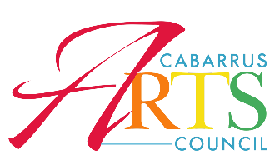
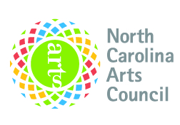
PROJECT ASSISTANCE GRANT GUIDELINES
Purpose
Non-arts non-profit organizations may apply for Project Assistance Grants. The purpose of this grant is to support programs of artistic merit that have community or statewide impact. Project Assistance Grants support exemplary forms of artistic expression in a variety of artistic disciplines.
Application deadline: January 22nd, 2024 at NOON via email to heather@cabarrusartscouncil.org

** If you already received funding for this fiscal year, you are not eligible this around. If you applied for funding in the fall but did not receive a grant, you are strongly encouraged to speak with Liz Fitzgerald for the panel’s feedback before resubmitting an application.

Eligibility
Organizations that meet the eligibility requirements may apply for Project Assistance Grants, however eligibility does not guarantee funding.
An eligible organization:
- Has tax-exempt status
- Is not an educational institution (Please contact liz@cabarrusartscouncil for Arts Education Grant)
- Is not a religious institution
- Project Assistance Grants may not be used to fund history programs.

Project Timeline
Funded projects should be completed between January 1, 2024 and June 30, 2024.

Matching Requirements
- Organizations may apply for up to 50% of the cost of the project.
- Grant funds must be matched in cash. In-kind contributions may not be considered for matching purposes, but may be documented as additional evidence of support.

Funding Requirements
- Project Assistance Grants may support artistic expenses directly related to the proposed project.
- Allowable fees may include artist fees, marketing, promotion, travel, contractual fees, rental or purchase of equipment and other project-related costs.
- Organizations may apply for only one arts council grant per cycle. Municipalities with multiple departments supporting projects should contact Liz Fitzgerald at liz@cabarrusartscouncil.org if you would like to submit a second application for consideration.
- To ensure that Grassroots arts programs reflect the racial and ethnic diversity of our county, Cabarrus Arts Council is required to spend a percentage of its annual county allotment on programming that reflects African American, Asian American, Latino and Native American cultures. We encourage organizations led by these communities to apply for your arts programming. Further, Project Assistance may be used by organizations to hire artists or ensembles of color to conduct arts programs.
- Project Assistance Grants fund project costs and may NOT be used for:
1. Administrative staff or general operating expenses
2. Activities concurrent with the project that are not arts-related
3. Food or beverages for hospitality or entertainment functions
4. Capital expenditures
5. Fundraising events

Application Procedure
- Grant Introduction Online Workshop: Tuesday, January 9th 4-5pm. RSVP to liz@cabarrusartscouncil.org to receive the link.
- Please email completed application and all attachments to: heather@cabarrusartscouncil.org.
- If you require assistance email liz@cabarrusartscouncil.org the week before your application is due. Staff may not be able to assist you the day applications are due.
- Final reports are due no later than NOON on June 15, 2024

