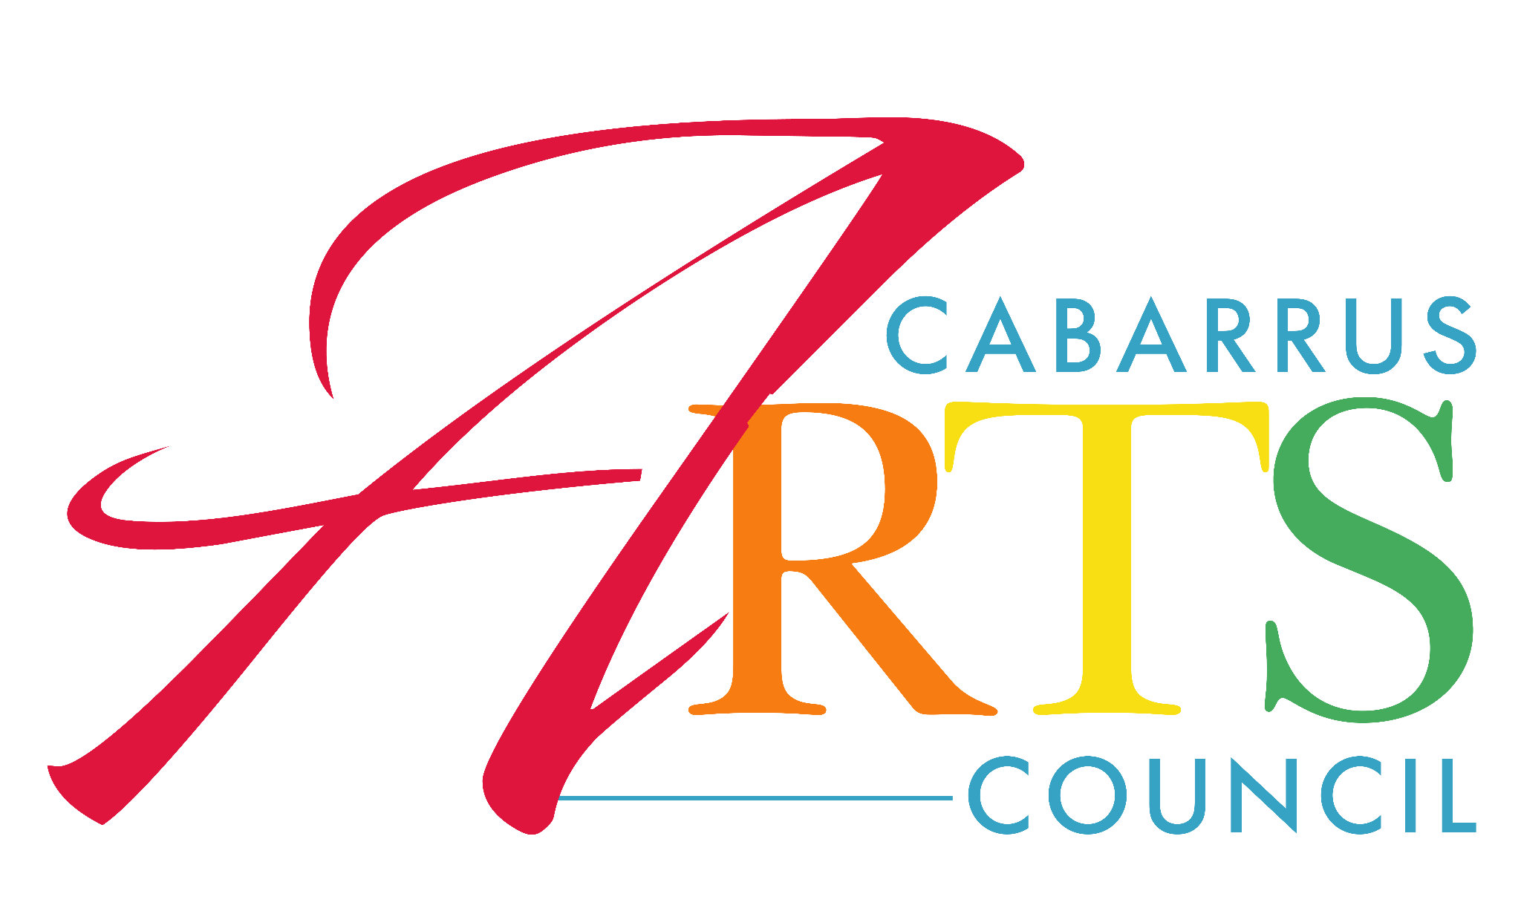
Special Thanks to our
2020-2021 Applause Society Members
The Applause Society is a group of individuals who give $1,000 or more to the Cabarrus Arts Council.

Susan R. Andersen
Gregory V. and Cordelia P. Andrews
Peter and Kelly Bailey
Kay Beckett
Georgi N. Brockway
Ruth Brooks
Angela Brown
Paul T. and Margaret Campbell
Karen Cobb
William and Debbie Dusch
Martin W. Ericson
Kimberly S. Gallagher
Wes and Letitia Harris
Anita B. Helms
Joseph and Nancy Hunter
Douglas G. and Cheryl K. Kelling
Jane Liles
John and Margaret Morrison
Cynthia Mynatt
Richard A. and Barbara R. Perry
Frank A. and Sharon O. Rankin
Anita R. Santa Cruz
Robert B. and Glenda G. Steel
Steve and Erika Steinbacher
Tri B. and Jennifer Tang
L. Darrell and Sandra C. Thomas
John W. and Kate Turner
James G. and Kay W. Wall
Barney and Margaret C. West
Dick and Jacqueline Whitfield
Christy E. Wilhelm and Billy Harrison Revocable Trust for Charity
Phyllis A. Wingate
Cynthia S. Wise

